AAA Absolute Stone

**Instructions**

Using the graph, draw the outline of your bench top according to your measurements (e.g. if the length of your bench top is 1700mm long, this should be shown as 17 squares long on the graph. If it is 650mm deep, this will be 6.5 squares, and so on)

Then mark out the approximate location of any required cut outs for under mount or drop in sinks, hot plates etc.

Then mark with an X the exposed edges of your bench top that are to be polished. (See example below)

If you require a splash back, draw a dotted line along the length of the bench top where the splash back will go. Please indicate the height of your splash back.

Once you have completed the drawing, fax, email or hand deliver it to us and we will contact you directly.

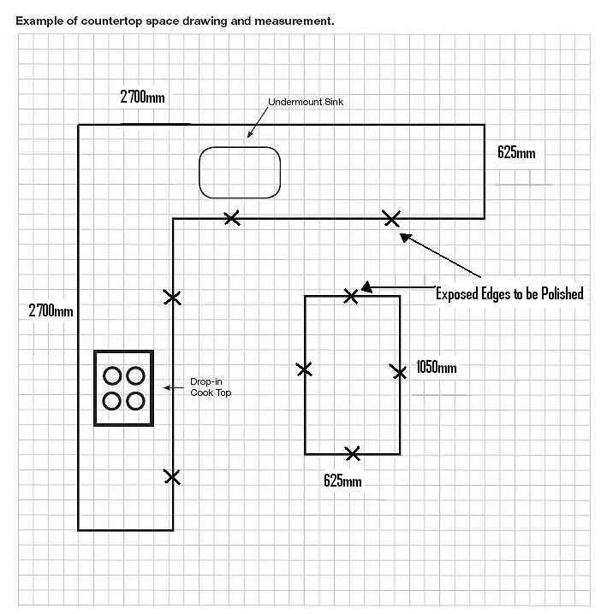

**Customer Name:** ________________________________________________ **Page: /**

**Address:** _______________________________________________________________________

**Ph:** _____________________ **Mob:** _______________________ **Email:** ____________________________________

**Fax:_____________________Thickness:**_________________________**Edge Profile:** __________________________

**Colours:** ________________________________________________________________

